## Documentation: Installation of the Versino Financial Suite Add-On

This guide describes the step-by-step installation and setup of the Versino Financial Suite Add-On for SAP Business One using the web-based SAP Extension Manager.

### Part 1: Installing the Add-On via the SAP Extension Manager

For the installation, you typically need two files: the add-on installation file (a zip file named Financial Suite LW YYYY.MM.DD.zip) and the module package (an XsPack file named VPSFinancial Suite YYYY.MM.DD.XsPack). In the first part, the add-on package is loaded into the system and assigned to the desired company database.

#### Step 1.1: Open SAP Extension Manager

In the SAP Business One Client, navigate to **Administration → Add-Ons → Add-on Manager**.

In the Add-on Manager window, click the link to go to the web-based SAP Extension Manager.

Ein Bild, das Text, Screenshot, Software, Computersymbol enthält.
Step 1.2: Log in to the SAP Extension Manager

1. A browser tab will open with the SAP Business One Extension Manager login page.
2. Log in with an authorized user (usually B1SiteUser).

Ein Bild, das Karte, Screenshot enthält.
Step 1.3: Import Add-on Package

1. After logging in, you will be in the **"Extensions"** tab.
2. Click the **"Import"** button.
3. In the "Extension Import Wizard," click **"Browse"** and select the .zip file of the Financial Suite Add-On (Financial Suite LW_YYYY.MM.DD.zip).
4. After the file has been successfully uploaded, click **"Next"**.
5. Confirm the successful import by clicking **"Finish"**.

Ein Bild, das Text, Software, Computersymbol, Betriebssystem enthält.
Step 1.4: Assign Add-on to a Company Database

1. Switch to the **"Company Assignment"** tab.
2. Select the desired company database from the list.
3. Click the **"Assign"** button to assign a new extension.
4. In the wizard, select the **"Financial Suite LW"** add-on and click **"Next"**.
5. Accept the default settings for parameters and start mode by clicking **"Next"** each time.
6. The add-on will now be displayed as **"Enabled"** for the selected company.

Ein Bild, das Text, Screenshot, Software, Computersymbol enthält.

#### Step 1.5: Start the Add-on in the SAP Business One Client

1. Restart the SAP Business One Client and log in to the previously selected company database. SAP will automatically install the add-on.
2. Navigate again to **Administration → Add-Ons → Add-on Manager**.
3. The "Financial Suite LW" will now appear under the available add-ons with the status **"Disconnected"**.
4. Select the add-on and click **"Start"**.

Confirm the following installation and start dialogs. The add-on will add new fields to your database, about which you will receive a notification.

Select the logging mode:

* + **Silent**: In this mode, only error messages and essential information about the process are displayed.
  + **Normal**: In this mode, all process information is displayed in detail. You should only select "Normal" if errors have occurred in "Silent" mode.

After the database has been set up, the add-on will start. A success message will then appear in the system message window at the bottom left.

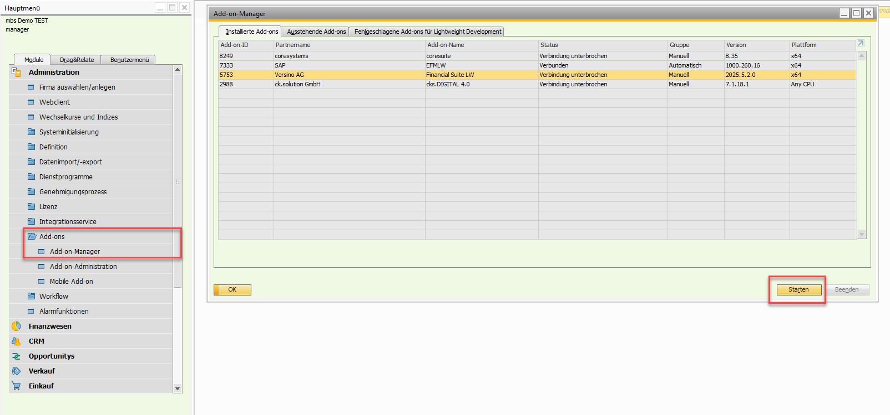

### Part 2: Module and License Import in Xs Admin

After the add-on has been started in the client, the specific modules and the corresponding license must be imported.

#### Step 2.1: Open XS Module Management

In the SAP Business One Client, navigate to **Administration → Add-ons → Xsphere Module → XS Admin**.

Ein Bild, das Text, Screenshot, Software, Computersymbol enthält.

#### Step 2.2: Import Modules

1. In the "Xs Module Management" window, click the **"Import"** button.
2. Select the module package file (e.g., VPSFinancialSuiteVYYYY.MM.DD.XsPack) to import all modules, or select individual module files.
3. The imported modules will now appear in the list.

**Note**: The "Start Priority" column determines the start order of the modules. The higher the number, the later the module starts.

Ein Bild, das Text, Software, Screenshot, Multimedia-Software enthält.

#### Step 2.3: Request License

1. Click the **"Request License"** button.
2. Save the %CompanyName%.LicPack file.
3. With the help of this file, your Versino contact person can create a license for you.

Ein Bild, das Text, Software, Screenshot, Computersymbol enthält.

#### Step 2.4: Import License

1. Click the **"Import"** button again.
2. Select the license file provided by Versino (e.g., %CompanyName%.Response.LicPack).
3. The license information (e.g., "Valid until") for the corresponding modules will be updated, then click the **"Update"** button.

Ein Bild, das Text, Software, Screenshot, Multimedia-Software enthält.

For verification, your license will be synchronized with the server. Each license is valid for use in up to four different databases. If you change servers, you will need to request a new license.